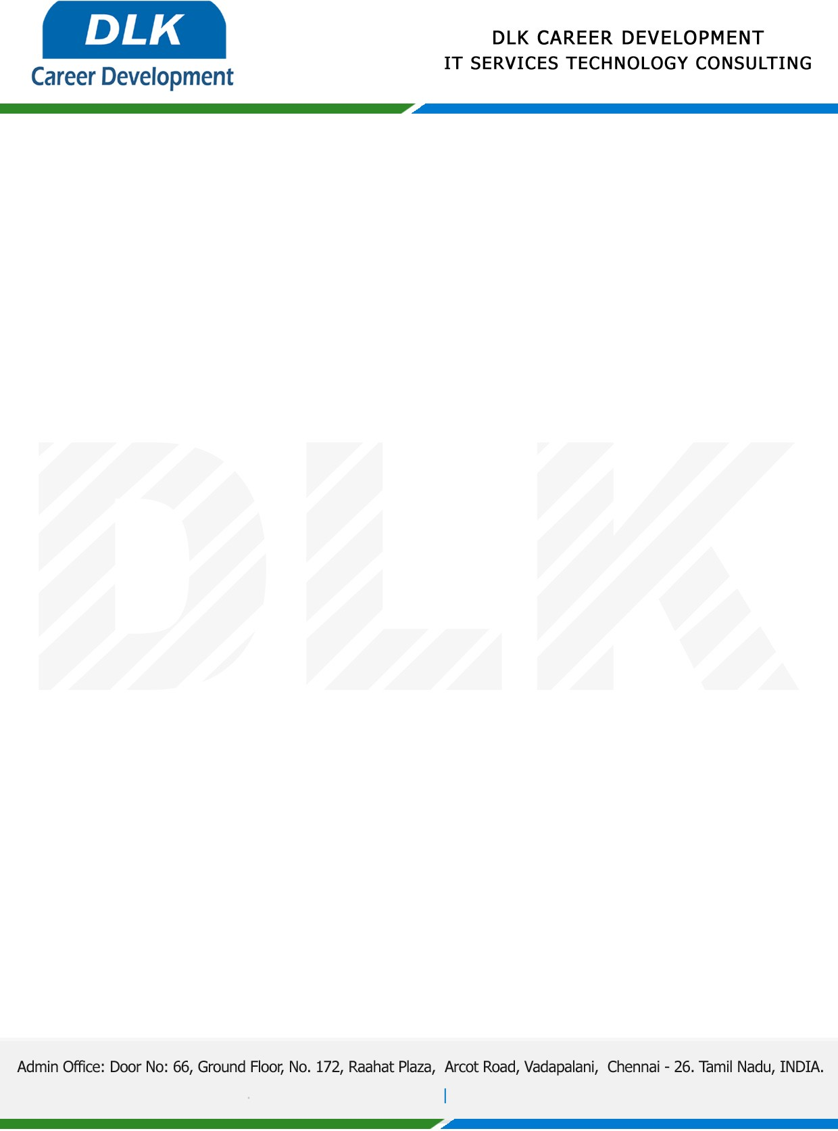

Date: 01/ December/ 2022

**To**

MCA- Computer Application,

Head of Department,

DR.M.G.R. Educational and Research Institute, Chennai.

**Sub: Letter of Project Acceptance**

This is to certify that **MR** **SARAVANAN M (REG NO: 214012101183)** Final year student has accepted the Project Work duration from **December 2022 to March 2023.**

**Domain:** Cloud computing

**Topic:** Combining Data Owner-Side and Cloud-Side Access Control for Encrypted Cloud Storage with EDOS

During the Project Work, all information and data collected from you should be kept confidential.

We appreciate your interest in **DLK CAREER DEVELOPMENT**

